Hot Takes challenge 1, Part B: proposal
Behavioural tracking and response intelligence. The thinking behind each choice is in my Part B notes; this is the proposal itself. Everything below is built and running in the Snack Moments prototype, unless I say it's future work.

1. Suggested tracking framework
I split the system into four steps. The browser only records what the player does. The server turns those events into scores and findings. The scores decide how much each answer counts and what the game does next. And the team's reviews and our random tests feed back in, so the engine gets better over time.
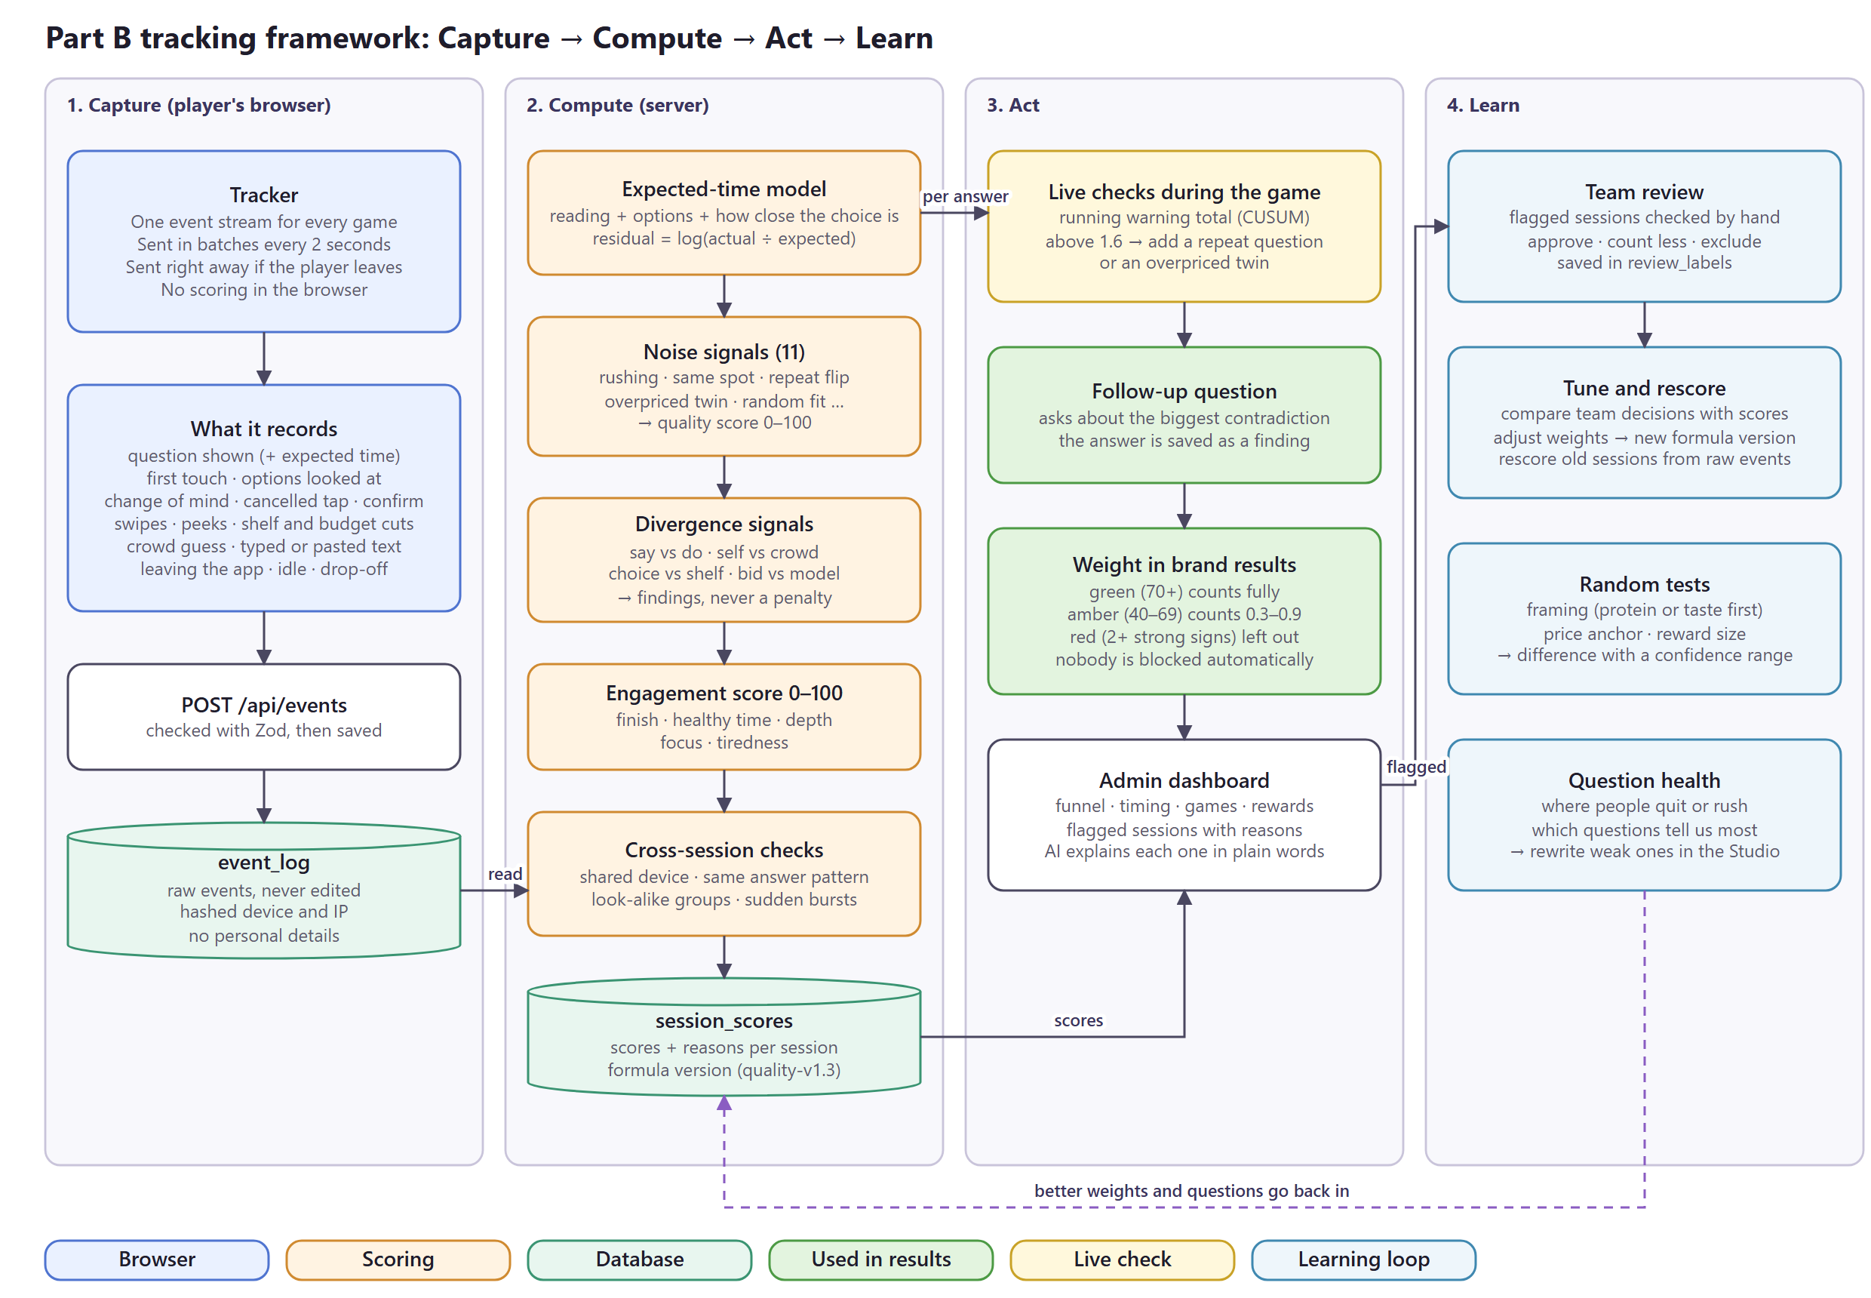
Part B tracking framework (editable: part-b-tracking-framework.drawio)
The rules I built it on:
- The browser never scores. It only sends events. All scoring happens on the server, so nobody can change their own score.
- Raw events are never edited. Scores are saved separately with a formula version (now quality-v1.3), so when the formula improves, old sessions can be scored again.
- Careless and contradictory are two different things. Careless signs lower the quality score. A gap between what someone says and does is a finding for the brand, never a penalty.
- Nobody is blocked automatically. The system flags with a reason in plain words, and a person decides.

2. Events and metrics I'd capture
Why each event matters is in section 3 of my Part B notes. This is the actual list the prototype records. Every game uses the same event stream, sent in batches every 2 seconds and right away if the player leaves the page.
Event | When it fires | What we keep
Choice rounds
item_shown | A question appears | question, round, expected time, test group
first_touch | First tap on the screen | time since the question appeared
option_focus | Player looks at an option | which option
option_change, tap_cancel | Changes their mind or cancels a tap | from and to
option_select, confirm | Picks and confirms | option, screen position, time taken
Other games
gut_swipe | Each swipe in Gut Check | snack, left or right, milliseconds
peek_reveal | Opens a hidden detail in Peek & Pick | which detail, in what order
label_peek_start / end, label_answer | Label Detective | how long they looked, their answer
shelf_add, shelf_remove, squeeze_start, squeeze_remove | Stock the Shelf and the budget cut | snack, price, what was cut first
bar_set, bar_squeeze_start, bar_cut | Build-a-Bar | points given to protein, taste and price
bid_locked | Bid It | moment and bid
crowd_adjust | Guess the Crowd | each move of the guess
week_overall, week_set | My Snack Week | whole-week total and each moment
text_paste | Typed answer | pasted or not, typing time, deletes
Whole session
visibility_hidden / visible | Leaves or comes back to the app | time
idle | No activity for 20 seconds | time since the last tap

Each session also stores a hashed device code, a hashed internet address, and the random test groups the player is in (framing and price anchor). Nothing that tells us who the person is.
How each metric is calculated
The list of metrics is in section 3 of my Part B notes. This is how I calculate them:
Metric | How it's calculated
Usable answers | Share of finished sessions in the green or amber band
Rushed answers | Share of answers made in under 35% of their expected time
Repeat agreement | Share of repeat questions answered the same way as the first time
Completion and drop-off | Sessions that reach each step ÷ sessions that started; also which question people quit on
Typical time per game | Median time per game, worked out on careful players only so a game isn't blamed for careless ones
Say vs do gap | The 1–5 rating minus a 1–5 score worked out from their choices
What protein is worth | ₹ per gram from each player's choice model, separately for desk/gym moments and late-night moments
Random test results | Difference between the random groups, with a 95% confidence range
Cost per usable response | Total study cost ÷ the sum of response weights (needs cost data, future)

3. How I calculate the quality and engagement scores
Expected time
A fixed “too fast” limit doesn't work, because some questions are harder than others. So every question gets its own expected time, and I compare the real time with it:
expected = 0.9 s + 0.26 s per word + 0.45 s per extra option
+ up to 2.2 s when the choice is close for this player
residual = log(actual time ÷ expected time)
rushed = residual < log(0.35) // under 35% of the expected time
Quality score (0 to 100)
Every finished session starts at 100. Each careless sign has a severity from 0 to 1 and a maximum number of points it can take away. Only careless signs are used here; contradictions never are.
Sign | What it means | Max points | Type
Rushing | Share of answers under 35% of the expected time | 36 | Strong
Overpriced twin | Picked the same snack at a higher price | 25 | Strong
Same screen position | 70%+ of taps on one spot (half), 85%+ (full), even though cards are shuffled | 22 | Strong
Quick games too fast | Gut Check under 350 ms a card, or Label Detective answered in under 1 s | 22 | Strong
Repeat flip | Changed answer when the same question came back, scaled by how sure their own model was | 18 | Strong
Random fit | Their choices fit their own preference model no better than 1.05× chance | 18 | Strong
Open text | Typed answer looks pasted or meaningless | 12 | Strong
Paid more for less | Refused a cheaper protein deal after taking a pricier one, in the same moment | 10 | Strong
Tapping rhythm | Tap positions repeat in a fixed cycle, like 1-2-3-1-2-3 | 8 | Weak
Flat timing | Hard choices take no longer than easy ones | 8 | Weak
Snack week total | Moments add up to far more or less than the whole-week answer | 6 | Weak

strong = number of strong signs with severity >= 0.5
penalty = sum(max points × severity) // weak signs only count if strong > 0
score = 100 − penalty
band = green if score >= 70, amber if 40–69, red if < 40
(red needs 2+ strong signs, otherwise it stays amber)
weight = green 1 · amber 0.3 to 0.9 (rises with the score) · red 0
The weight is how much the session counts in brand results. Red sessions are left out until someone on the team checks them; they are never deleted or blocked.
Engagement score (0 to 100)
Part | Points | How it's earned
Finished | 35 | Full points for finishing; otherwise 3 per answered question, up to 25
Healthy time | 25 | Share of answers between 45% and 4× the expected time (not rushed, not distracted)
Depth | 15 | Options looked at plus changes of mind per question (full points at about 1.2)
Focus | 15 | Loses points each time the player leaves the app; 0 after 3 times
Tiredness | 10 | 10 if they don't speed up in later questions, 5 if a little, 0 if a lot
Trust across studies
Each player has a trust level that builds up over studies. It starts at 0.67 and moves towards their usual quality. Older studies slowly count less, so a player can recover from one bad session:
after each study: a = a × 0.9 + weight b = b × 0.9 + (1 − weight)
trust = a ÷ (a + b) // starts at a = 2, b = 1

4. How I'd identify response bias and suspicious behaviour
Bias: compare answers that should agree
I can't ask people if they're trying to look good, so I compare two answers to the same question that come from different games. These gaps are saved as findings and never lower the quality score:
Gap | What it compares
Say vs do | The 1–5 rating, asked last, with what their choices show
Self vs crowd | How much they say protein matters to them with what they guess others pick
Choice vs shelf | Protein in single choices with protein in the weekly basket
Gut vs choice | Quick swipes on protein snacks with slower, priced choices
Bid vs model | What they bid for a protein bar with what their choices say it's worth
Design vs choice | How much protein their designed bar has with how much protein matters in their choices
Moment gap | ₹ per gram at the desk or gym with ₹ per gram late at night
Budget cut | Whether protein snacks are the first thing cut when the budget drops

The biggest gap for each player triggers one follow-up question at the end, with four possible reasons (for example price, taste, the moment, or not available). Their answer is saved as a finding, so the brand learns why, not just that.
Suspicious behaviour inside a session
While the game runs, every answer adds warning points: +0.9 if it was rushed (under 35% of the expected time), +0.4 if it was quick (under 55%), +0.35 if it's on the same spot as the last tap, and +0.35 if the pick is very surprising for this player. A running total (CUSUM) adds these and subtracts 0.5 each answer. If it goes above 1.6, the next question is a check: a repeat question or an overpriced twin. Every session also gets one of each anyway, so careful players are checked too.
Suspicious behaviour across sessions
Check | How it works
Shared device | The same hashed device code used by more than one player
Same answer pattern | Sessions with the exact same order of tap positions and swipes
Look-alike groups | Sessions grouped by behaviour (speed, tap spread, model fit, swipe speed, leaving the app, length) using k-means; the 5% furthest from any group are marked as outliers
Sudden bursts | An hour with at least 4× the usual number of new sessions

The role of AI and how I tell a decisive player from a rushing one are in section 3 of my Part B notes. In short, AI explains flagged sessions and checks typed answers, but it never sets a score, and speed only counts as careless when the choices also stop making sense.

5. How I'd use this data to keep improving the research engine
Loop | What happens | In the prototype
Team review | Reviewers mark flagged sessions as approve, count less or exclude. Their decisions are compared with the score to tune the weights and cut-offs | Labels built; tuning needs real players
Rescoring | A new formula gets a new version, and old sessions are scored again from the raw events | Built
Random tests | Players are randomly shown protein-first or taste-first cards, and different starting prices. The difference between groups is shown with a confidence range, so the team knows the change caused it | Built; reward-size test is next
Question health | For each question: where people quit, how often it's rushed, and how much it tells us. Weak questions are rewritten in the Studio, where one AI model rewrites and another reviews for bias | Built
Smarter question order | The next question is the one we'd learn the most from for this player, and the game stops once we know enough (4 to 10 rounds) | Built
Fair game comparison | Optional games are rotated, and results are re-weighted (inverse probability weighting) so the rotation doesn't bias them | Built

Future work: once the team has reviewed enough real sessions, learn the weights from their decisions instead of setting them by hand, and tune cut-offs like “35% of the expected time” on real players, checking how many honest people get flagged by mistake.

